**Register for IBM Cloud**

Team ID : PNT2022TMID09881

Project Name : A Novel Method for Handwritten Digit Recognition System

**DHANUSH PRAVEEN D**

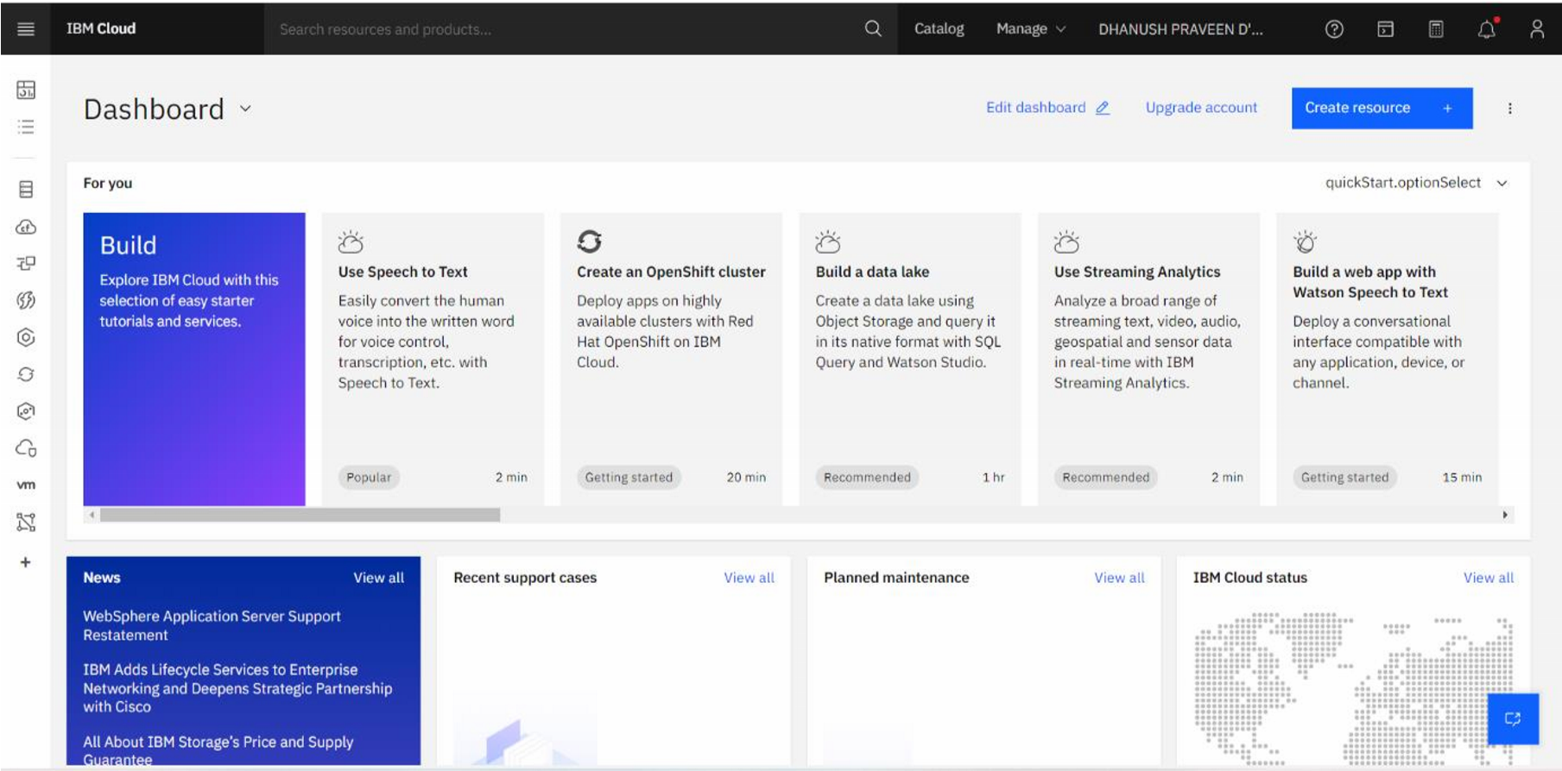

**SHIVANI S**

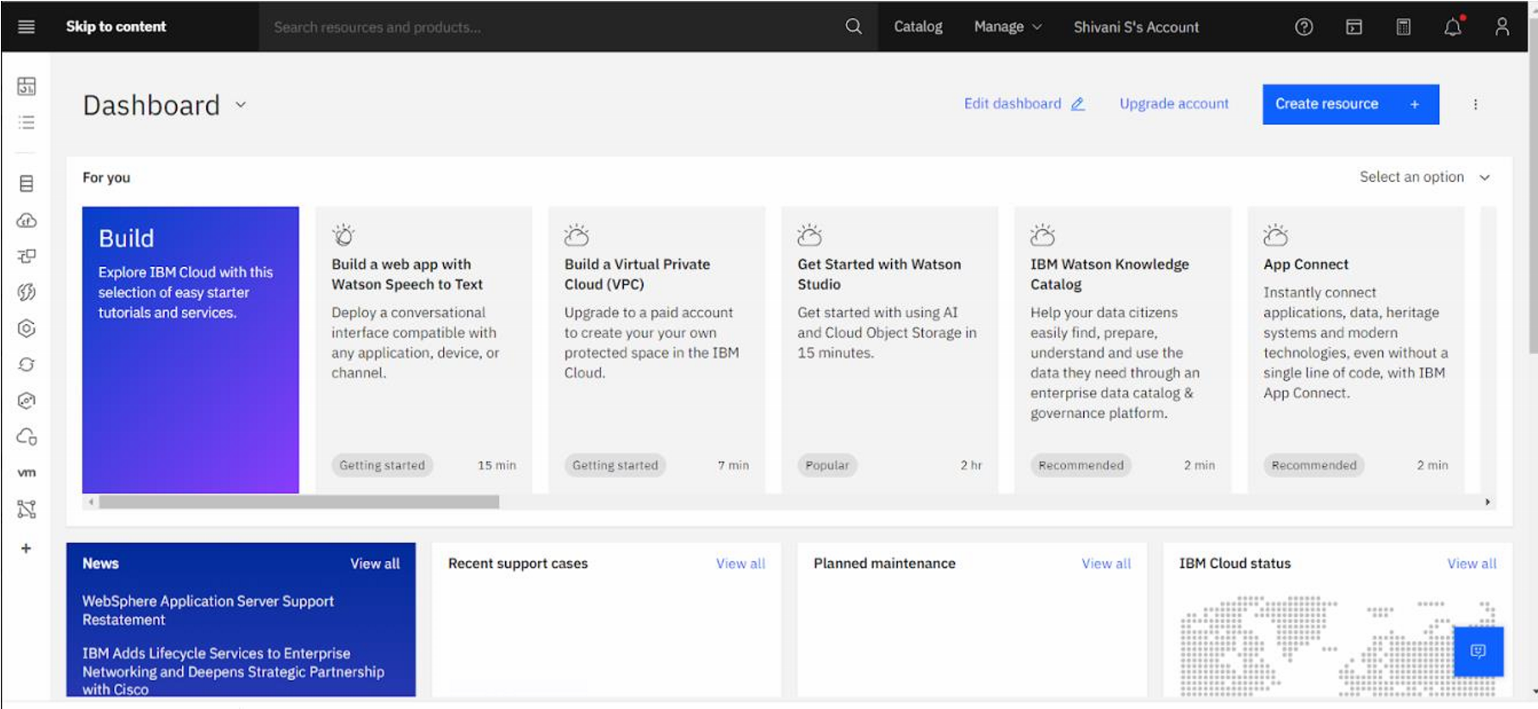

**SWETHA J**

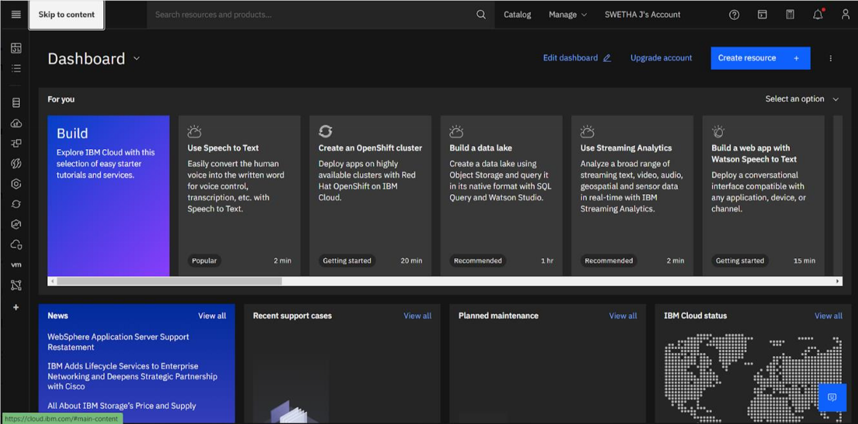

**GEERTHANA J**

